Information Technology Solutions

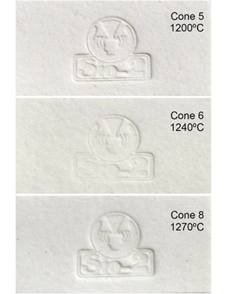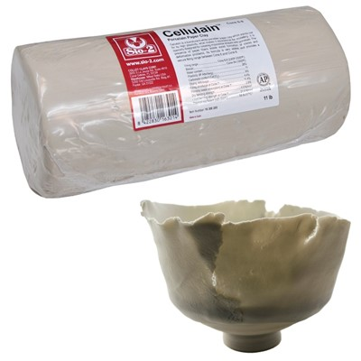

**Cellulain® is a translucent white porcelain paper clay that stands out for its high plasticity.**

**While porcelain clays typically have lower plasticity and mechanical strength compared to other clays, the inclusion of paper fibers in Cellulain® allow for much higher moldability. This allows for the creation of extraordinarily thin and complicated shapes or objects.**

**The presence of paper fibers also helps avoid the formation of cracks and deformations. The fibers are burned off during firing, so it is advised that your kiln room is well ventilated.**

**Following firing, the porcelain clay will retain its shape- including extremely delicate and transparent areas, resulting in an extraordinarily stunning finished product.**

**Firing range: Cone 6-8 (2269-2320ºF)**

**Biscuit temperature: Cone 06 (1855ºF)**

**Water content: 26%**

**Plasticity (IP Atterberg): 11**

**Carbonate content (CaCO3): 0%**

**Drying shrinkage: 4.4%**

**Firing shrinkage (1250ºC): 11.4%**

**Porosity (water absorption at 1250ºC): 2.8%**

**Dry bending strength: 4.5 N/mm2**

**Fired bending strength (1250ºC): 21.0 N/mm2**

**Thermal coefficient (25-500ºC): 58.8x10-7ºC-1**

SIO-2® Cellulain® -Porcelain Paper Clay

**WHAT IS PAPER PORCELAIN?**

**Paper porcelain is a specialty clay that has paper fibers mixed into the body. It provides a higher plasticity than typical porcelain clays.**

**WHY CHOOSE CELLULAIN®?**

**Cellulain® is specially formulated to allow potters the ability to craft extremely thin or complicated objects without cracking or deformation.**

**IS CELLULAIN® CLAY SUITABLE FOR TABLEWARE (FOOD-SAFE)?**

**Yes. Cellulain® clay bodies are food-safe according to ISO 6486:1999 standards.**

**CAN I USE THIS CLAY ON A POTTERY WHEEL?**

**Cellulain® clay is great for both wheel throwing and modelling.**

info@sandtastik.com

P: 905-734-7340

F: 905-734-7733

www.sandtastik.com